1. What are three conclusions we can make about Kickstarter campaigns given the provided data?
   1. Based on the provided data we could conclude that it would be in the project starters best interest to begin their Kickstarter campaign within the first half of the year, particularly keeping it running through May. This is due to the higher concentration of successful projects within this month, and a downward trend from there on, with the worst month to maintain a Kickstarter project being the month of December. While failed projects remained relatively constant, the ratio of successful projects ton failed projects seems to be earlier in the year.

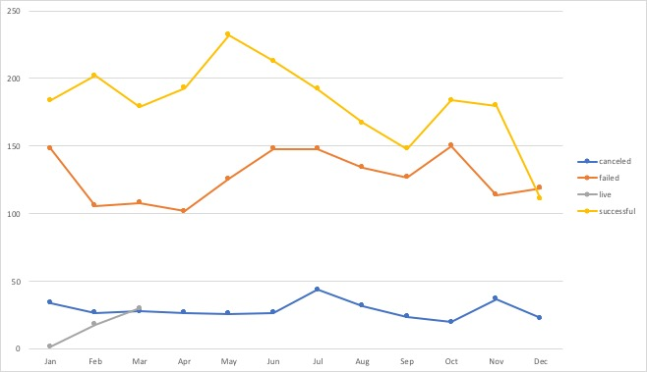

* 1. According to categorical data, it would be advisable to direct a Kickstarter project toward the category of “music”. This is due to the relatively high success rate of 77.14% of the projects within that data set were successfully completed within their timeframe. This is in comparison to the “theater” category which has the next highest success rate at 60.22 % and the “journalism” category which had the worst numbers at complete cancellation of all projects. Also, it is advisable to specify the categorical delineation down into its sub-category of “rock” because of the 100% success rate within that subcategory. This also follows the trend of the previous conclusion in that success rates were highest at the beginning of the year and continued with a downward trend to the end of the year.

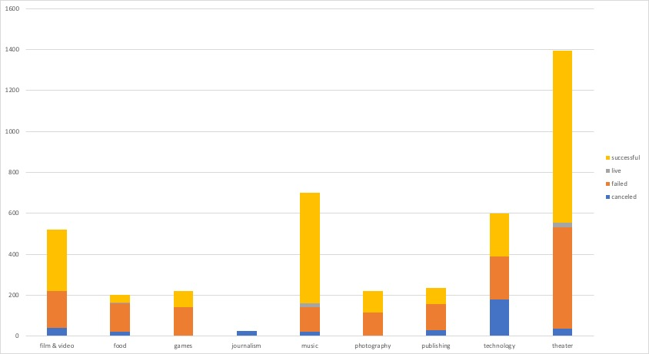

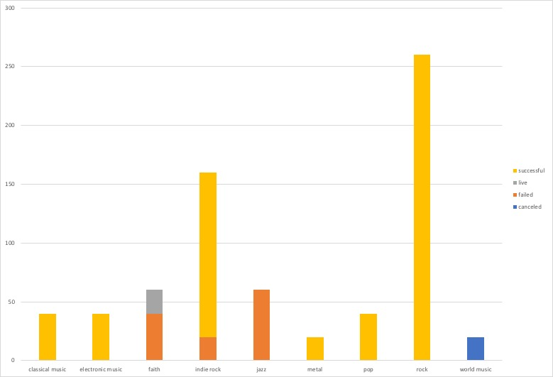

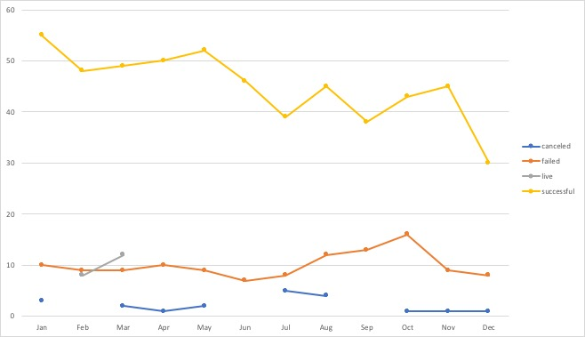

* 1. Lastly, it would appear that the category with the most cancelled projects would be the “technology” category. Within “technology,” only three categories made up all of the cancellations: “space exploration,” “wearables,” and “web”. This could be due to the fact that a lot of Kickstarter projects are so-called “vaporwear” that will never see the light of day, or alternatively that when large companies see great ideas within tech, the web, wearables, and space exploration, they purchase these ideas outright.



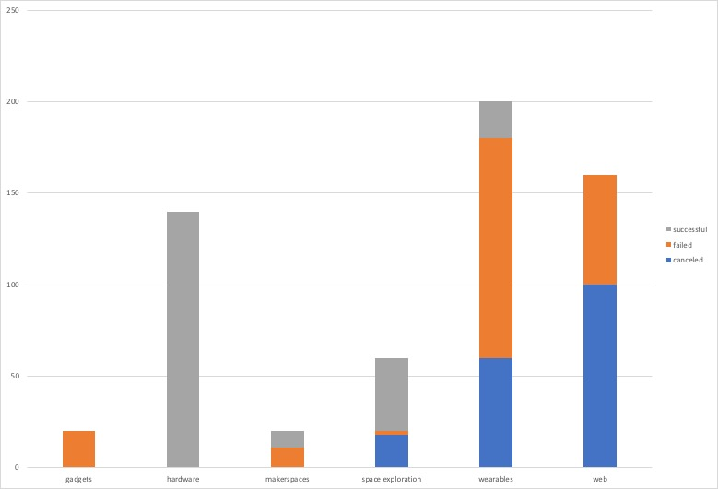

1. What are some of the limitations of this dataset?
2. Limitations of this dataset would be that there is no representation of whether the project was immediately successful or it took the full time to gain success or failure. There is no category to explain what the perks of funding the project netted the investor, thus limiting our ability to know if the backing was due to fair compensation or the project was not funded due to insufficient compensation. There are also no backer data such as age, wage, sex, etc. This leads to a lack of knowledge about backers and who should be targeted with projects in each area.
3. What are some other possible tables/graphs that we could create?
   1. Another possible graph we could have made would have been a bar graph that showed projects and their success rate that were staff picks versus non-staff picks. Number of backers or average donation amount versus success rate to show whether each project was backed by a few large donations or many small donations. This would help to indicate target market (as referenced in the previous question) by leading to a general idea of backer’s wage. Finally, we could have made a graph to analyze the goal amount versus the success rate. This would help to indicate whether there was a limit to how much backing one should ask for in their projects.